**What is the reality?**

**Water transfer, not river linking**First let us understand what happened in Andhra Pradesh on Sept 16. The Chief Minister was to inaugurate the first pump (of the what is going to be a battery of 30 pumps) as part of the Pattiseema Project to lift water from Godavari River from a location about 15 km downstream of the proposed Polavaram dam site and transfer it to an intermediate canal of about 5 km length to already constructed Polavaram Right Bank Canal, which will take it to Krishna River near Ferry/ Ibrahimpatnam village in Krishna district, just upstream of the Prakasham barrage/ Vijaywada city (see the SANDRP map). Reports said that the Pattiseema pump did not start, and the water that was being transferred on Sept 16 was being pumped by the existing Tadipudi Lift Irrigation Scheme, a couple of kilometers downstream from Pattiseema. The reports said: “The government has decided to draw 500 cusecs of water from the Tadipudi lift scheme with the help of three pump sets to make Pattiseema scheme operational on an ad hoc basis due to non-completion of the latter’s works.”

The Pattiseema project involves 30 Nos of Vertical Turbine pumps, each of 8 cumecs (Cubic Meters per Second) capacity. The Pattiseema pump could be switched on only on Friday, Sept 18, to be switched off the next day, see for details below (due to a massive leakage in the canal).

The first thing that is clear from this is that this is essentially transfer (by pump) of water from Godavari to Krishna. This cannot be called River Linking. To label it so would show lack of understanding of what is a river. River is not just the water that Pattiseema pump was attempting to transfer from Godavari. The claim of river linking by such water pumping is clearly a false, misleading claim.

By Sept 24, 2015, two pumps were installed and two more had arrived the site, but in response to a controversy, [the Chief Engineer accepted tha](http://www.thehindu.com/news/cities/Vijayawada/canal-works-will-be-completed-by-next-june/article7688217.ece)t the pumps were only temporarily borrowed from the Handri Neeva Scheme! So it seems even the pumps used at Pattiseema were borrowed from a Rayalseema project. The Cheif Engineer confirmed that the water transfer would be stopped “by November” to complete the works related to the canal.

**Project needs Environment clearance under EIA notification, but has not secured it**As the Minister of Andhra Pradesh (AP) Water Resources Department Shri D Uma Maheshwara Rao said, Pattiseema project involved removing about 1.3 crore cubic meters of sand from the Godavari River Bed. The kind of work involved in this project can also be seen from the photo album of the project put up on the AP Irrigation Dept website. The Pattiseems project “is likely to throw up new environment and ecological issues affecting agricultural production in thousands of acres en route, damaging the delicate biodiversity and inducing climatological changes in the uplands of West Godavari and Krishna districts… Transfer of such a large quantity of water from one river to another without conducting a proper environment impact study will do more harm than good” warns environmentalists. In fact *the Times of India* report rightly concluded: “The state government should take up environment impact study through a third party and take remedial measures before releasing water into the canal.”

What is clear from all this is that Pattiseema is a major new irrigation project with major components and impacts on the river and surrounding area. Pattiseema Project was not part of the Polavaram project. However, Pattiseema project has not sought or got the environment clearance that is necessary prior to undertaking any such activity. It has not conducted environment & social impact assessment & management plan or public consultations. Effectively, it has bypassed environmental appraisal and scrutiny completely! What this means is that at this moment, the whole of Pattiseema project is in violation of the EPA 1986, EIA notification of Sept 2006 and is illegal. Some of us have written a letter to MoEF to this effect on Sept 17, 2015, the letter can be seen at Annexure 1. No response has been received from the MoEF or the EAC on this.

**Baseless claim that Pattiseema is for domestic and industrial water use!**The AP govt GO dated January 1, 2015 that sanctioned the Pattiseema project gives some details of the Pattiseema project with stated cost of Rs 1300 crores, the cost has reportedly now gone up to Rs 1400 crores. The GO misleadingly says that the project is for “domestic and industrial use” when in reality, as is apparent from the statements of the AP Chief Minister, Water Resources Minister and others, it is essentially for irrigation benefits for the Krishna Delta area immediately and Rayalseema in future. For example, the reports said: “Thousands of farmers in Krishna, Guntur, Prakasam, Kurnool, Kadapa, Anantapur and Chittoor districts will gain from the Godavari-Krishna linkage.”

This is also clear from the fact that there are no details as to how this water will be used for domestic and industrial use, either in the GO or anywhere else including in the statements of the CM and others. This baseless claim has been added to mislead everyone and possibly escape the need for clearances as per the EIA notification.

**CWC and techno-economic clearances not taken**Section 84 of the AP Re-organisation Act, 2014 requires the AP and Telangana governments to get projects like Pattiseema, involving the use of Godavari and Krishna waters duly appraised, among others, by the Central Water Commission (CWC), before they can be undertaken. Apparently, even this requirement stands infringed. Since the Pattiseema project involves Krishna and Godavari, both interstate rivers, it also needs CWC approval, in addition to getting the Techno-Economic approval from the Technical Advisory Committee of the CWC, which have also not been taken.

**Pattiseema to benefit already irrigated area?**Currently, Pattiseema project is transferring water that the Krishna delta farmers can use. But Krishna Delta is already irrigated with water from Srisailam-Nagarjunsagar. The under construction Pulichintala Dam is also supposed to benefit the same Krishna Delta. As Dr D Narasimha Reddy told SANDRP, the Pattiseema project is going to benefit the same area that is already benefiting from more than one project. The ultimate beneficiary of this transfer, it is claimed will be the drought prone Rayalseema area. Some say that this is indeed Naidu’s move to cut the popularity of rival Jagan Mohan Reddy in Rayalseema area.

**Can Rayalseema benefit from Pattiseema?** It is suggested that when Pattiseema irrigates Krishna Delta, the water that will be saved in upstream Srisailam Dam can be used by Rayalseema region. Dr. Y. V. Malla Reddy, Director of Anantpur based AF-Ecology Centre says that there are essentially two projects through Rayalseema can possibly use Srisailam water: Pothireddypadu and Handri Neeva. Both are essentially gravity cum lift irrigation projects, taking water from Srisailam back waters only when water level at Srisailam dam is above 854 feet. The trouble is that neither of the projects are fully ready, nor is the Srisailam dam water likely to reach anywhere near 854 feet this year or in most years, so this claim of Pattiseema benefiting Rayalseema would need a large pinch of salt to believe.

**The Power Cost** The reports, say: The PLIS consumes 2.712 million units a day, which is nearly half the daily power consumption of the entire Vijayawada City, including its industrial units. The total power needed for operating 24 VT pumps each of 350 cusec discharge capacity with 24 synchronous motors of 4.7 megawatts capacity each require a whooping 113 mw. The unit cost of the power for lift-irrigation purpose is Rs 5.64. That is, the total cost of power consumption a day for the project stands at Rs 1.53 cr. The Pattiseema Lift Irrigation Scheme has been designed to release water at the discharge rate of 8,500 cusecs. The government intends to divert 80 TMC of Godavari water through the PLIS to Krishna. Even if the project continues to work 24×7, it will take about 90-95 days to pump out 80 tmcft of water. Even if we take the minimum amount required for the project to pump the total 80 tmcft of water, the cost of power consumed will come to 90 days x 1.53 cr, that is Rs 137.7 cr. This is only the cost of power and if the costs incurred on other heads like maintenance, etc., are taken into consideration, the total cost incurred for the diversion of the water from Godavari to Krishna will be much more.

**The donor Godavari basin also includes Marathwada** The most compelling logic of Inter linking of rivers proposal is supposed to be transfer of water from water surplus to water deficit areas to solve problems of both the basins. In the case of the Godavari Krishna River Link, Godavari is the donor basin and Krishna is the recipient basin. Donor basin is supposed to be water surplus basin. However, Marathwada, India’s most drought hit region this year and in recent years, is also in Godavari basin! Marathwada had till recently the highest rainfall deficit of 52%. Even after some good rains in last couple of weeks, its total monsoon rainfall is just over 400 mm! With what stretch of imagination can we say that this Godavari basin is surplus in water, ready to transfer to a needy basin?

**The recipient Krishna basin donates 120 TMC water annually to Konkan** The needy basin, in this case is Krishna basin. If Pattiseema does function as designed, it can transfer 80 TMC (Thousand Million Cubic Feet: 1 TMC = 28.17 Million Cubic Meters, 80 TMC = 2253.6 MCM, but for sake consistency, we will use the unit of TMC that is more popular in the south) of water in a normal year. However, this so called water deficit, needy, recipient under the link under discussion, the Krishna basin, every year transfers about 120 TMC water to high rainfall Konkan area through Tata and Koyna dams and further down to sea! And that water profligacy of Krishna basin is on display this year too! If we add the figure of virtual water export that Krishna basin does through its sugar production in Maharashtra and Karnataka, that figure would go up manifold. Under these circumstances, how can we describe Krishna basin as needy, needing water transfer from another basin?

**This is not the first Godavari Krishna River Link (GKRL)** The media described this pumping of water through Pattiseema as the first Interlinking of Rivers and Mr Naidu called it first confluence of Godavari and Krishna waters. In reality this is the third interlinking between Godavari and Krishna in Andhra Pradesh alone. The first GKRL happened during British period, about 160 years ago when the two rivers were linked for navigation. As *the Times of India* reports: “The Eluru canals from Godavari and Krishna meet at Malkapuram village to form part of the Kakinada-Pondicherry Buckingham canal.” About the second GKRL link, Dr D Narasimha Raddy wrote to me, “A 18-km pipeline connecting effluents collected in Manjeera basin, a tributary of R. Godavari, links with River Musi, a tributary of R. Krishna.” So what Mr Naidu inaugurated on Sept 16, 2015 is possibly the third Godavari Krishna link in Andhra Pradesh, not the first.

In addition, as comment to this blog from JPGL pointed out, there are several schemes in Telangana pumping water from Godavari basin to Krishna basin: “There are already four working lift water schemes in Telangana state transferring Godavari or its tributary (Manjira) water to the Krishna basin. These are Manjira water supply to Hyderabad located in Musi/ Krishna basin, irrigation water supply from Sriram Sagar reservoir across Godavari to Musi, etc tributary basins of Krishna river, Hyderadad drinking water supply from Yellampalli barrage across Godavari and irrigation water supply from Devadula lift irrigation scheme from Godavari river to Musi, etc tributary basins of Krishna river. In addition there are four more lift irrigation schemes under implementation such as Pranahita Chevella lift irrigation scheme, Kanthalapalli lift irrigation scheme, Rajiv Dummugudem lift irrigation scheme, Indirasagar Rudrammakota lift irrigation scheme, etc in Telangana to transfer/lift water from Godavari river for high lands irrigation in the Krishna basin.”

So clearly there are multiple other schemes already doing what Pattiseema has started down on Sept 16, now abandoned due to the breach in the canal.

**The Interstate ramifications** Since Godavari and Krishna are interstate rivers, any water transfer between the two rivers is bound to have interstate ramifications. Firstly, the Krishna Water Tribunal has directed that out of 80 TMC water that is to be transferred from Godavari to Krishna, Andhra Pradesh share is 45 TMC and rest is to be shared between Maharashtra and Karnataka. However, that was the situation before formation of Telanganga. Now with the bifurcation of AP, Telangana will also get a share of water from what AP was to get earlier. In fact petitions are pending in Supreme Court as to what should be the mandate of Krishna Tribunal in the aftermath of the bifurcation, whether KWDT should only decide distribution between AP and Telangana or should all four states be involved in fresh water sharing? In addition, there is the outstanding dispute related to the Polavaram Dam impact, involving Chhattisgarh, Orissa and now possibly Telananga. There are suits pending in the Supreme Court on these issues. Polavaram’s environment clearance also remains challenged and stands suspended by MoEF.

Incidentally, while the impacts and costs of the project will have to borne by Andhra Pradesh, the water transferred will have to be shared with the basin states, particularly since Andhra Pradesh did not share the project details with the basin states, nor got their consensus.

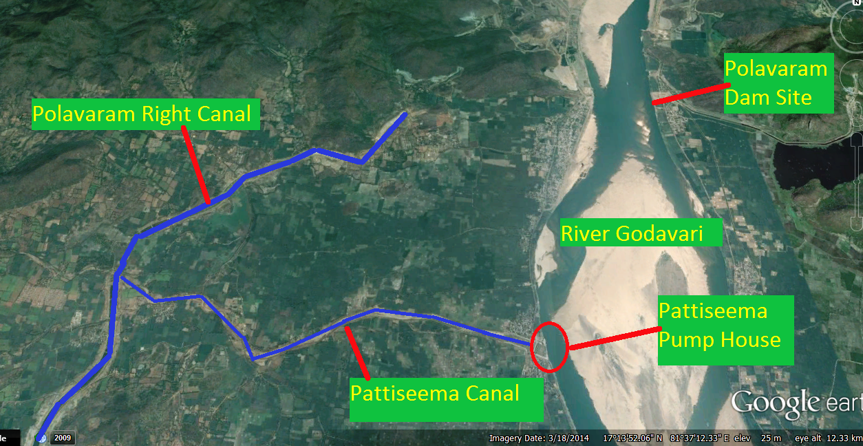

*Pattiseema Googla Earth Map*

**Why do sections of Andhra Pradesh polity see Pattiseema as wasteful expenditure?**The Pattiseema project is to essentially pump about 80 TMC of water from Godavari to Krishna. This was one of the several other objectives of the Polavaram dam. Andhra Pradesh CM Naidu decided to implement Pattiseema considering the uncertainties related to Polavaram dam, there is question mark over if and when the Polavaram dam will come up. So the AP government took the unilateral decision to implement the Pattiseema project at a huge cost of Rs 1400 crores. When Polavaram project becomes a reality, Pattiseema will be redundant since the transfer will happen through gravity by the Polavaram dam and pumping will no longer be required. This is why there is opposition to Pattiseema among many in AP, as wasteful expenditure. Many also see it as a Naidu’s ploy to get credit for the water transfer that was already happening through Polavaram.

**The Leakage in the Transfer!**The hurriedly inaugurated water transfer has already “received a big jolt within hours after launching the motors”, as the Polavaram Right Bank canal has already developed massive leaks at Janampet village where Tammileru river crosses the canal. The leakage is so massive that the Pattiseema pump & Godavari Krishna water transfer have been stopped so that the damaged canal can be repaired. An aqua-duct constructed at an expense of Rs 15 crores has breached, leading to damages and stoppage of water transfer, see the map prepared by SANDRP. “We have been suspecting the danger as we were not allowed to work as per the rule book. The breach is the result of completing the work without giving proper time for curing,” said an engineer of water resources department. With the Naidu government insisting to be the first to link the rivers as part of National River Linking Scheme, the officials raced ahead of time and rolled out the project with half or partially-dug canal work. The engineers could finish the digging of canal just for about 20 metres width against the original design of 80 metres width along 174 km long canal. The repairs could take 2-4 weeks.

Even a pro ILR editorial in *the Pioneer* accepted: “Finally, it goes without saying that the Government itself must do its homework properly, including thorough environmental assessments and financial calculations, and then ensure proper implementation. A poorly constructed aqueduct in the Godavari-Krishna link, for example, breached within hours of the motor pump being turned on. This should not become the norm.” The trouble is, lack of thorough Environmental Impact Assessment, manipulated economic, hydrological and financial calculations and corruption ridden and poor construction are the norms.

This shows that Pattiseema project was hurriedly inaugurated when neither the Pattiseema pumps were available, nor the link canal was ready, the whole thing was a misleading show!

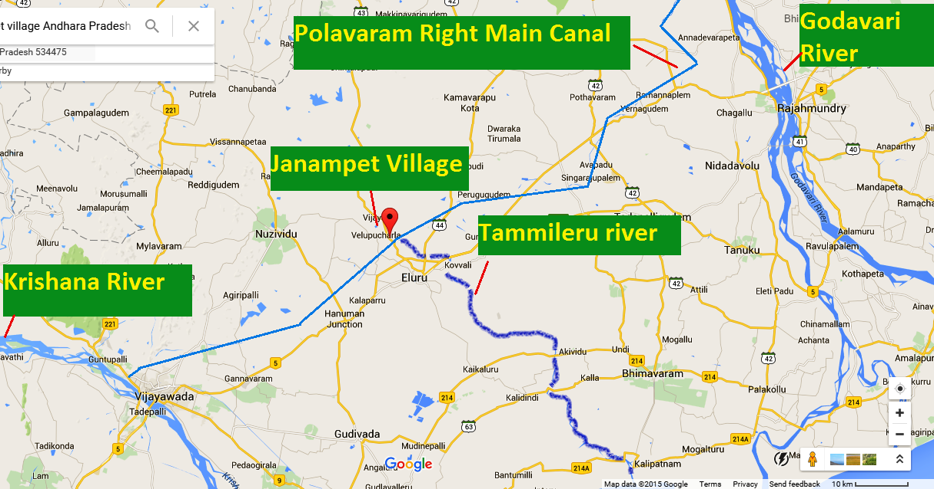

*Godavari Krishna Breach map*

**In Conclusion**While it is possible that such a water transfer could help Krishna Delta for now when almost all of the reservoirs in the Basin in Andhra had low water shortage, we cannot afford to sideline the reality that a project has been constructed, completed and celebrated in full public glare, without going through the statutory process and obtaining required clearances. We also need to note the consequences of undue hurry, the full ramifications of which are still unfolding. Moreover, there are serious question marks over the justification of transfer of water from a basin that is drought stricken to a basin from where more water is being transferred to high rainfall area and sea than what this transfer at best can achieve.

Such dramatic quick fixes are easy to appreciate and appear as if they are a result of courageous and prompt decision making from the highest quarters. However, such one-sided decisions and projects which bypass the laws of the land and bypass objective & informed scrutiny & democratic process do not bode well for the future of the nation or future of water resources in India.